Feature Post or Banner ( Card )

We will create this

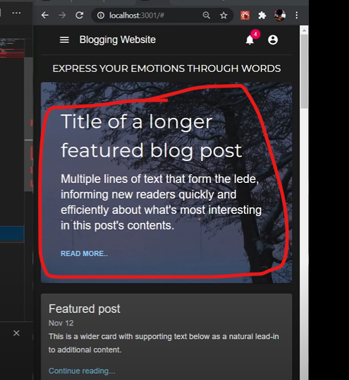

Create a component as Featurepost.js

& call it in app.js

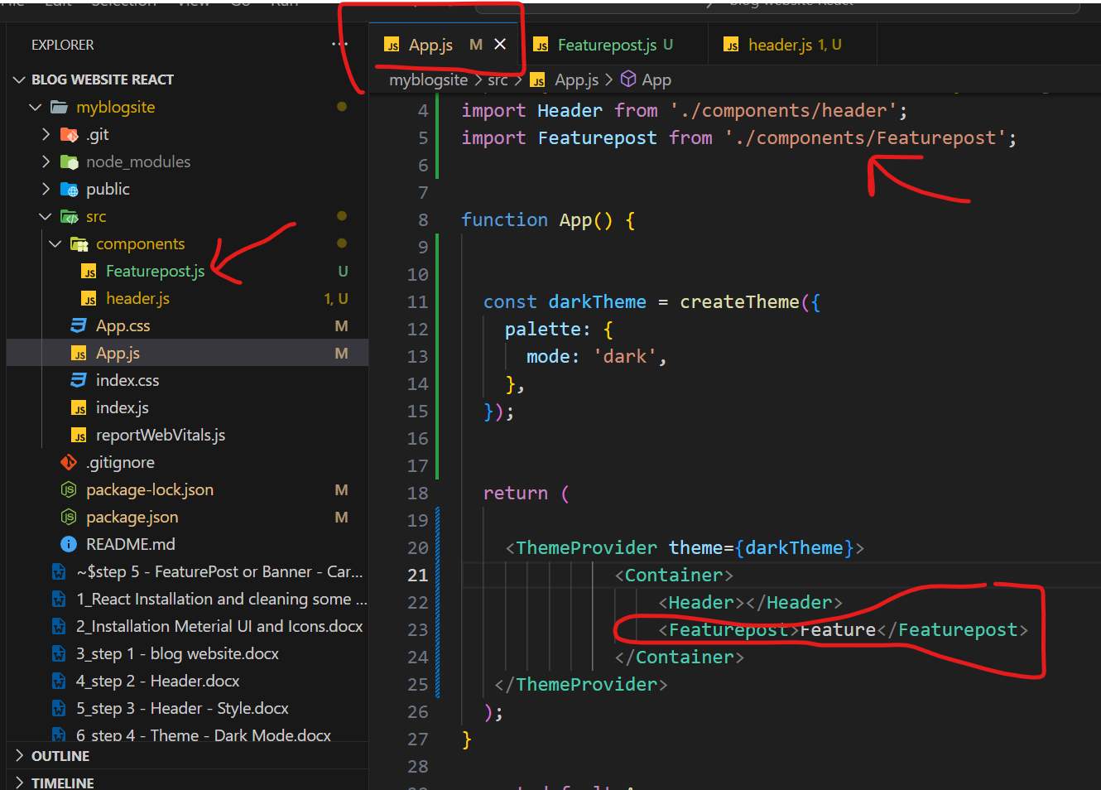

O/P

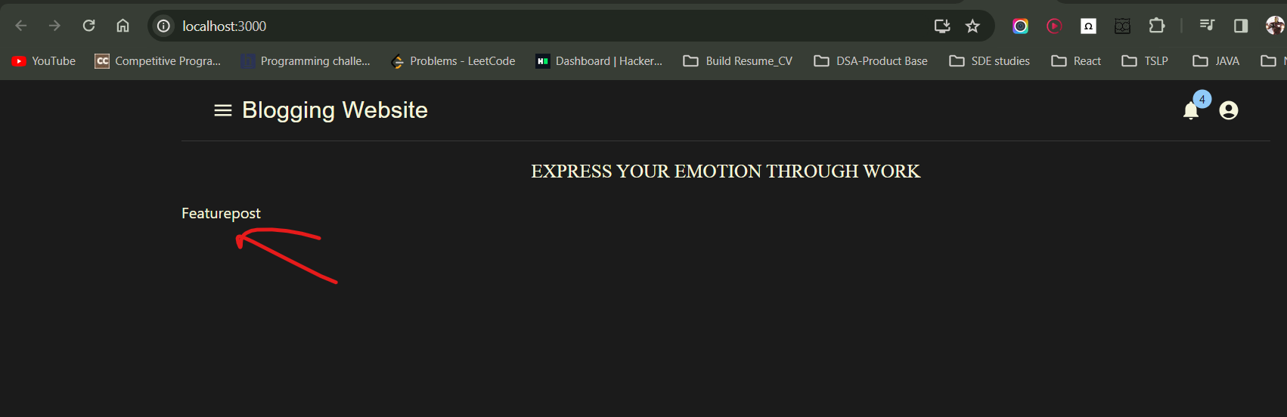

**MIUI – CARD**

( Card, Cardcontent, Cardaction, )

In MUI website search card

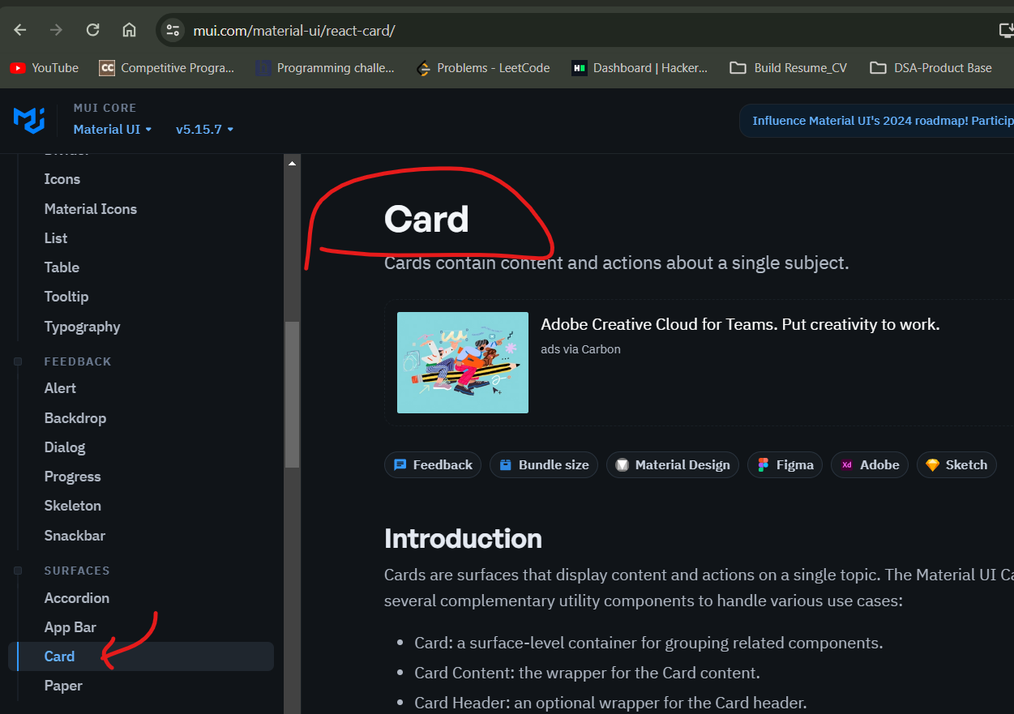

Import card and cardcontent and use it

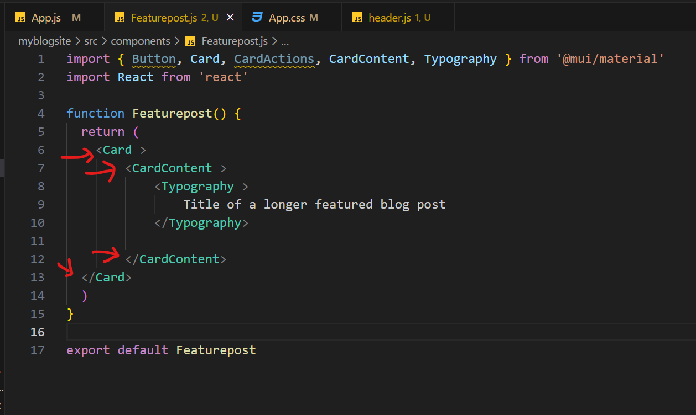

O/p

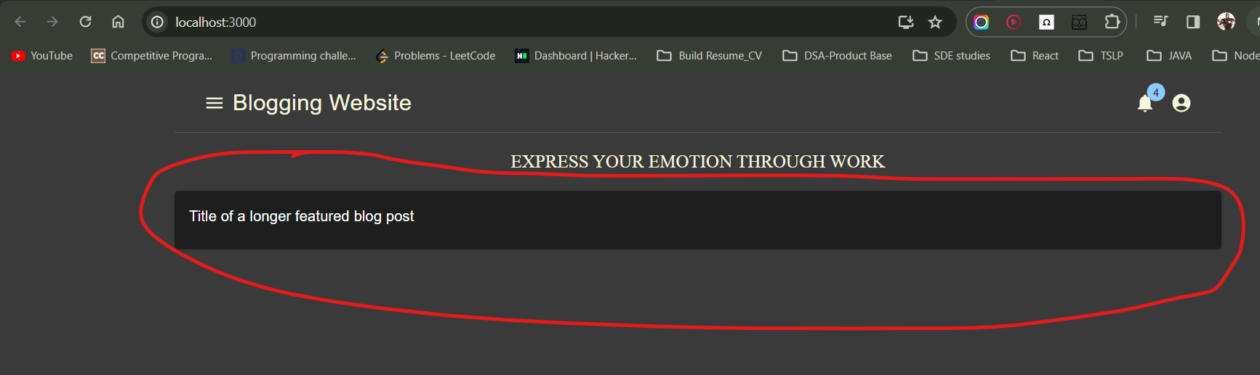

Whole code

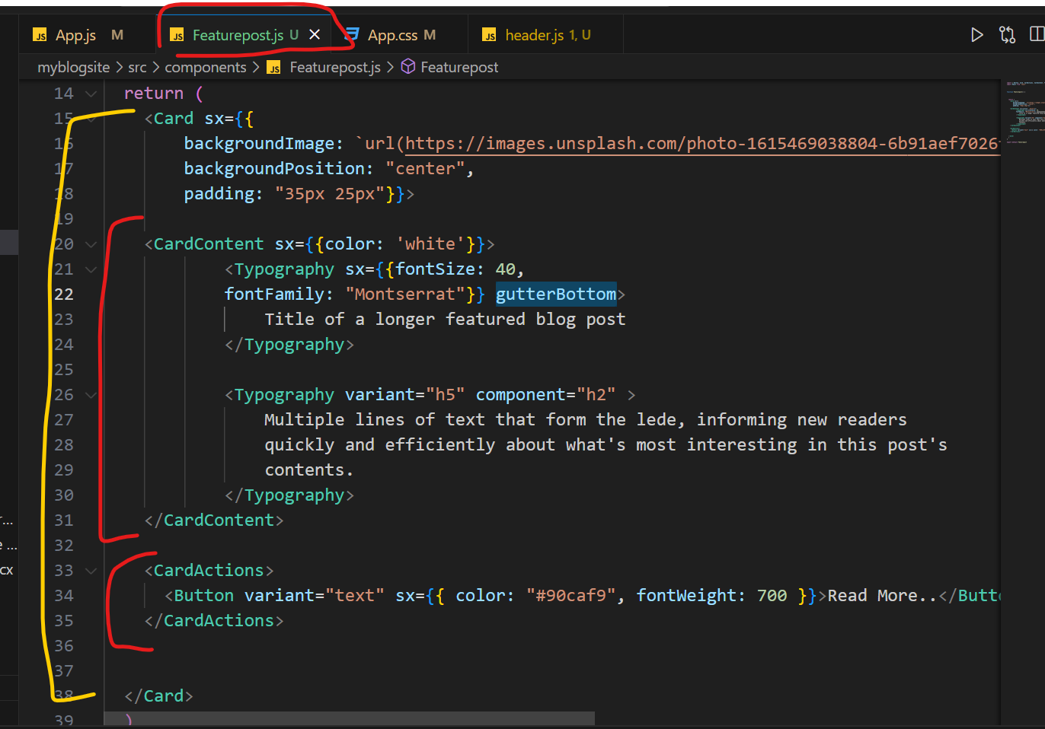

gutterBottom -> it gives some vertical space between 2 typography

o/p

